🌳 Tree Revision Sheet
Pattern 1: DFS (Recursion)

Ask yourself:
Go to the left.
Go to the right.
Combine the answers.

Return.
Used in:
- Height
- Count
- Sum
- Maximum
- Diameter
- Balanced
- LCA

Pattern 2: Height
Question:
Longest path from root to leaf.
return Math.max(left, right) + 1;

Pattern 3: Count Nodes
Question:
How many nodes?
return left + right + 1;

Pattern 4: Sum of Nodes
Question:
Sum of all values?
return root.data + left + right;

Pattern 5: Maximum Value
Question:
Biggest value?
return Math.max(root.data,
Math.max(left, right));

Pattern 6: Search in BST
Question:
Smaller?
Go Left.
Bigger?
Go Right.

Pattern 7: Invert Tree
Question:
Swap
left
↓
right
Then recurse.

Pattern 8: Balanced Tree
Question:
Difference of heights.
Math.abs(left - right) <= 1

Pattern 9: Diameter
Three possibilities.
Left Diamete
Right Diameter

Left Height + Right Height + 1
Take the maximum.

Pattern 10: LCA
Three cases.
Found in Left
↓
Return Left
----------------
Found in Right
↓
Return Right
----------------

Found in Both
↓
Return Root

🌳 BFS Pattern
Always remember this skeleton.
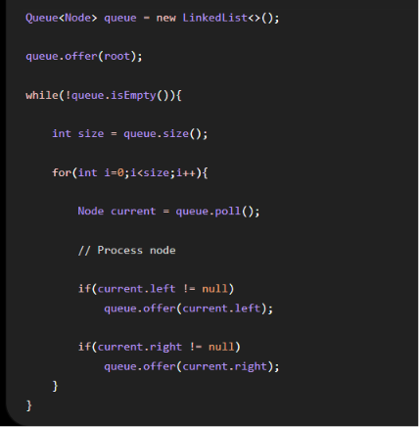

Level Order
Print every node.

Left View
if(i == 0)

Right View
if(i == size - 1)

Zigzag
Use a list.
Print:
- Normal
- Reverse
Toggle direction.

Top View
New concept:
Horizontal Distance (HD).
Root = 0
Left = HD - 1
Right = HD + 1
Store the first node for each HD.

Bottom View
Exactly the same.
Store the last node for each HD.

⭐ Most Important Interview Patterns
By now, you should recognize these immediately:
Problem | Pattern
Height | Math.max(left, right) + 1
Count | left + right + 1
Sum | root.data + left + right
Maximum | Math.max(...)
Search BST | Left/Right comparison
Invert | Swap children
Balanced | Height difference
Diameter | Height + Diameter
LCA | Return Node
Level Order | Queue
Views | Queue + Level
Top/Bottom | Queue + HD + TreeMap

